**BDD - Behavioral Driven Development Testing L1**

**Trend NXT Hands-on**

**Assignment-2**

STEP 1: Launch Open Cart application

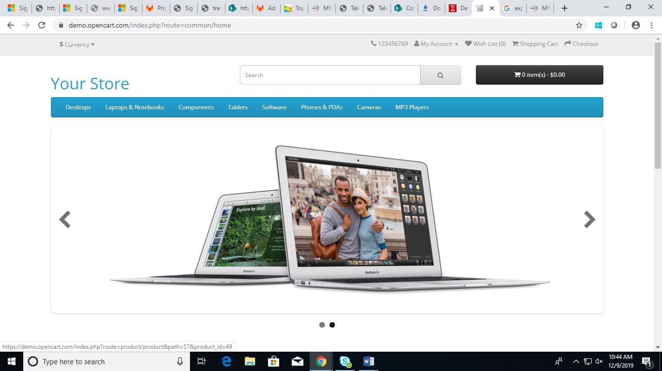

STEP 2: Click on "Login" Link

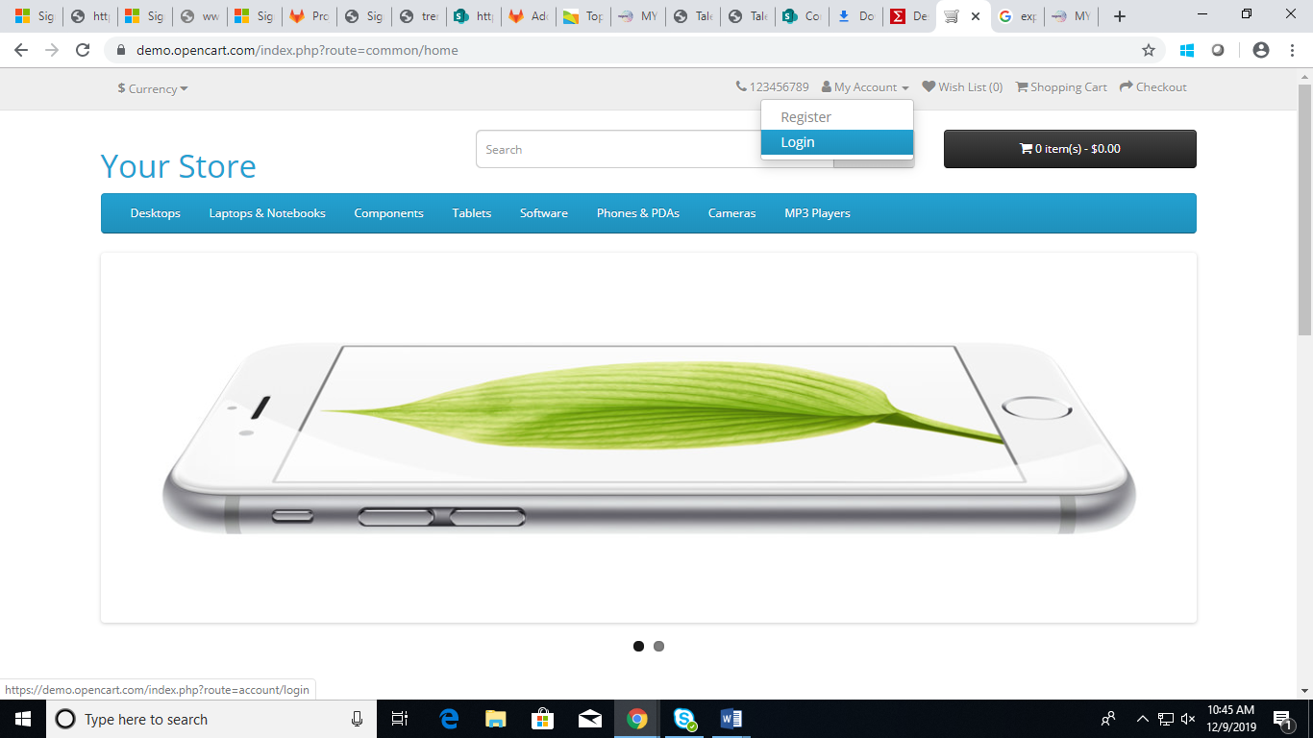

STEP 3: Enter the key word in search text box on top right of the page. Hit Enter button only and no icon click

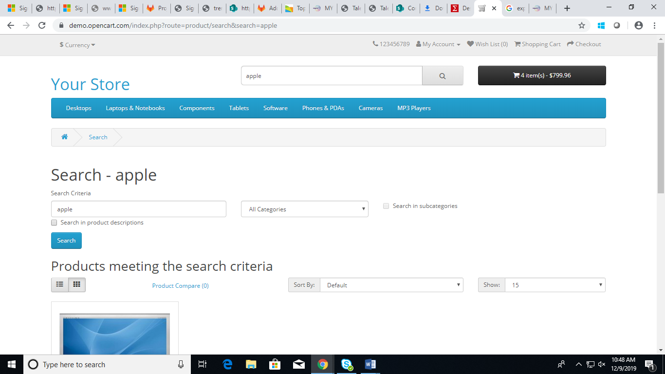

STEP 4: Select "Monitors" under Components in the drop down. Check "Search in sub categories" and click Search

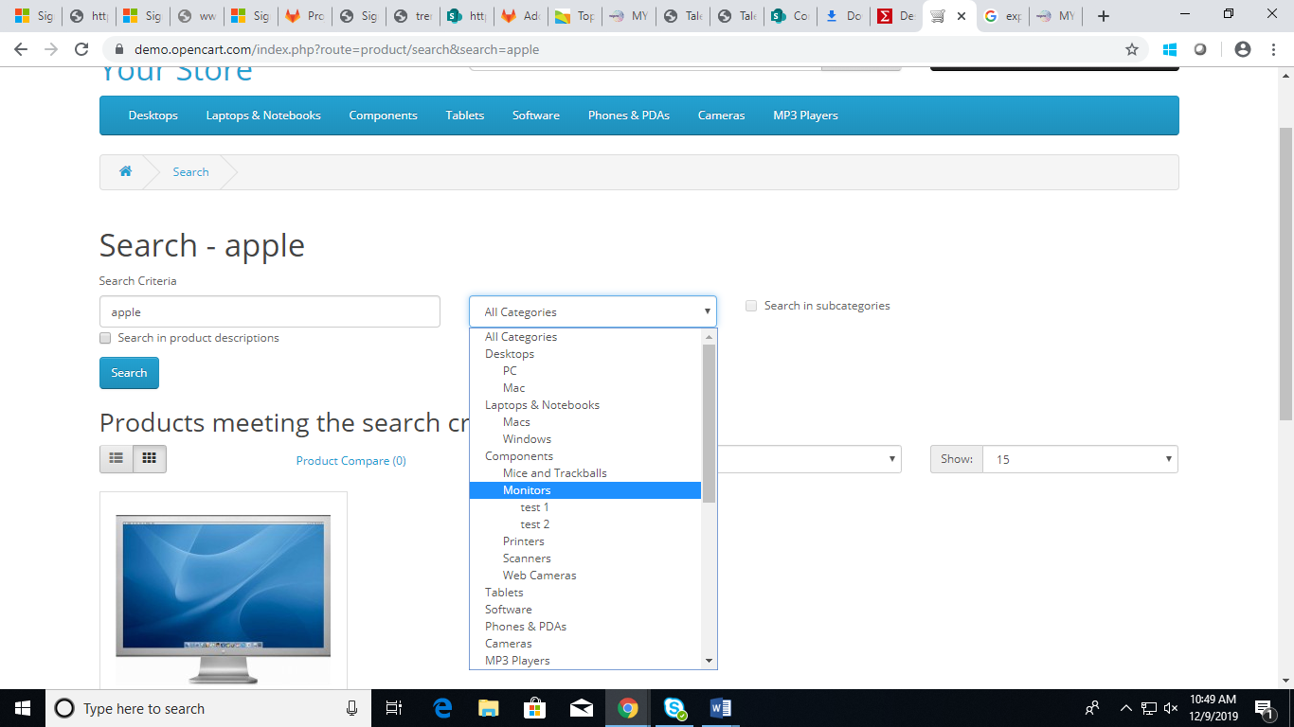

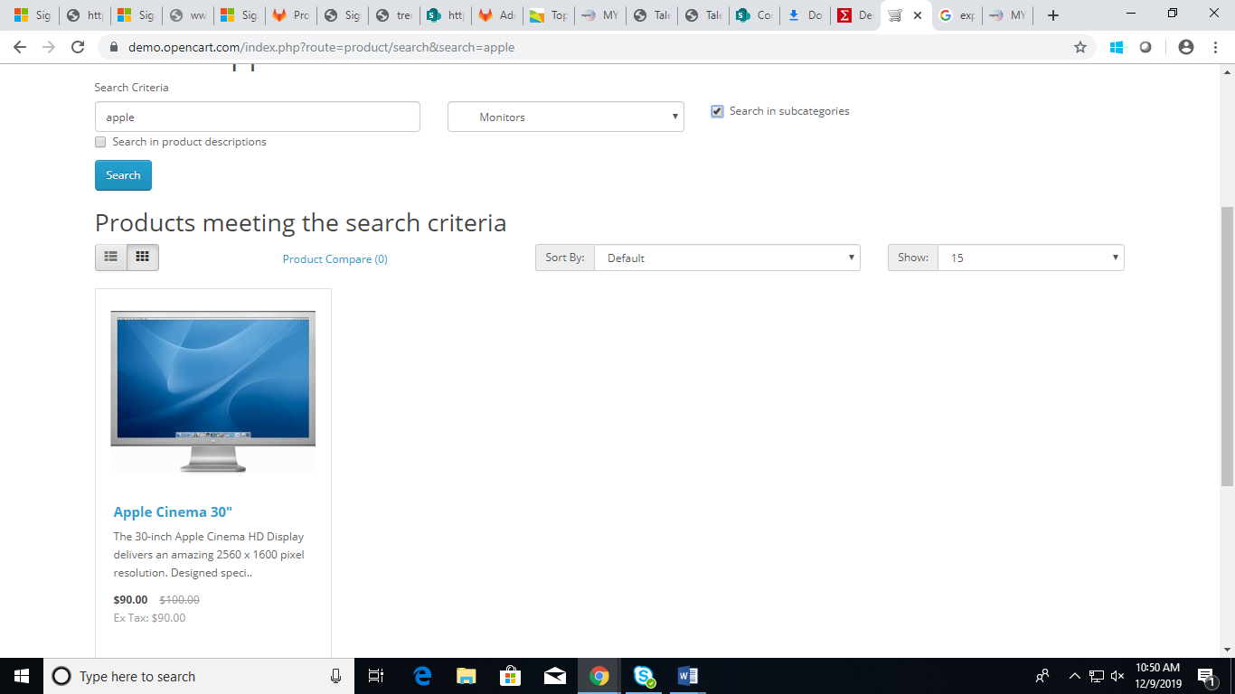

STEP 5: Click on "Phones and PDA's" tab.

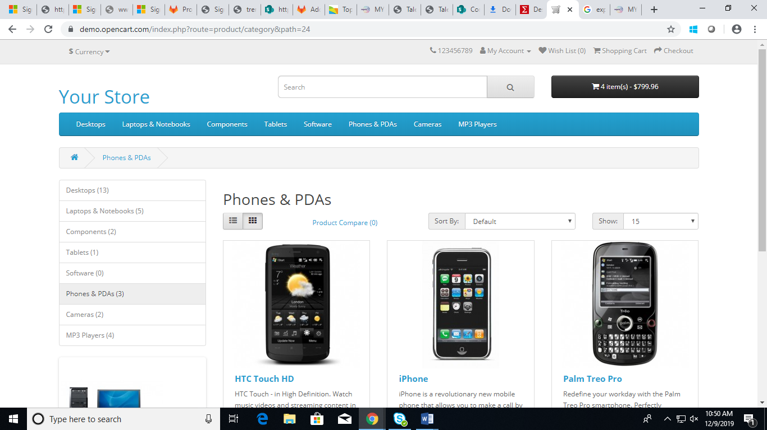

STEP 6: Sort from the "Price (High > Low)" for the page

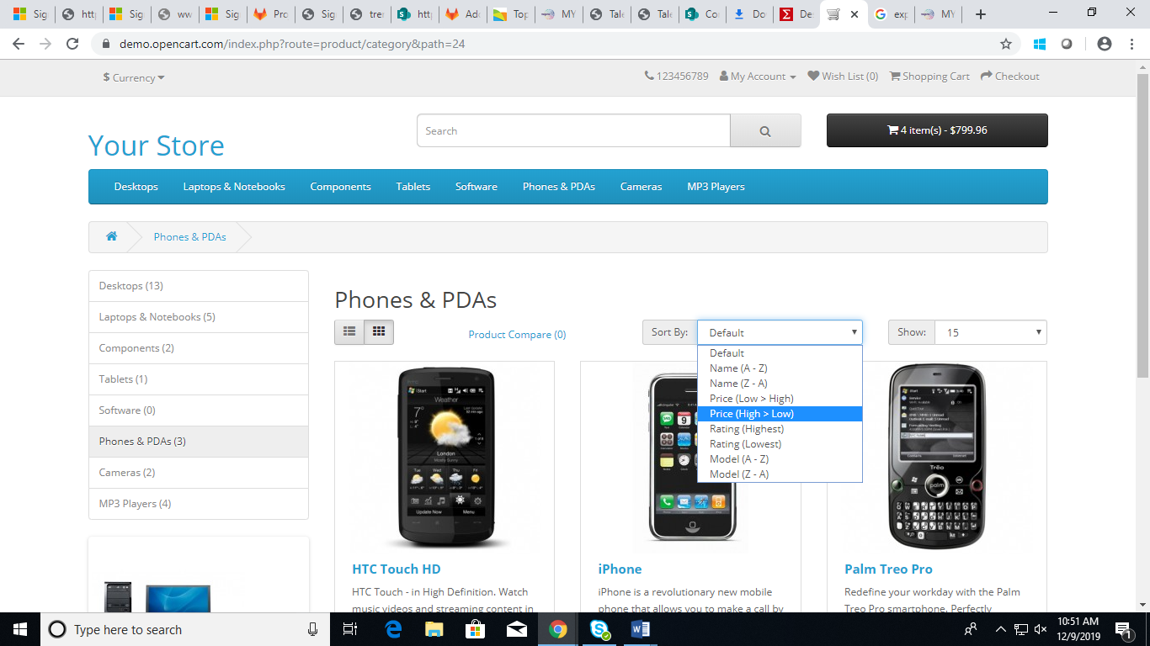

STEP 7: Click on "Add to Compare " for the first three phones" and click on Close button

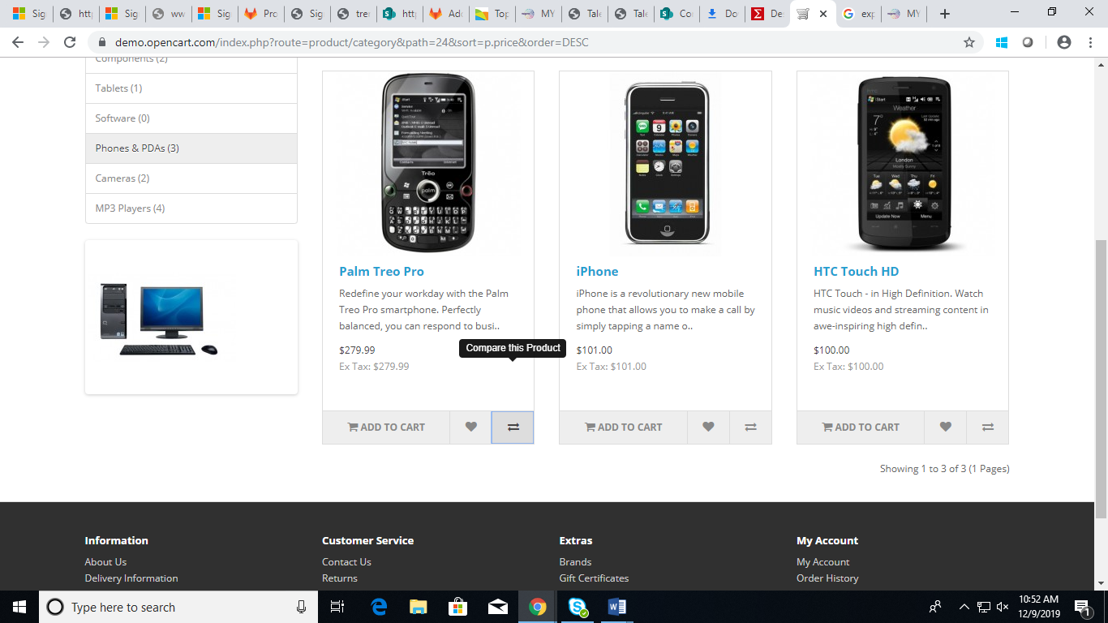

STEP 8: Click on "Product Compare"

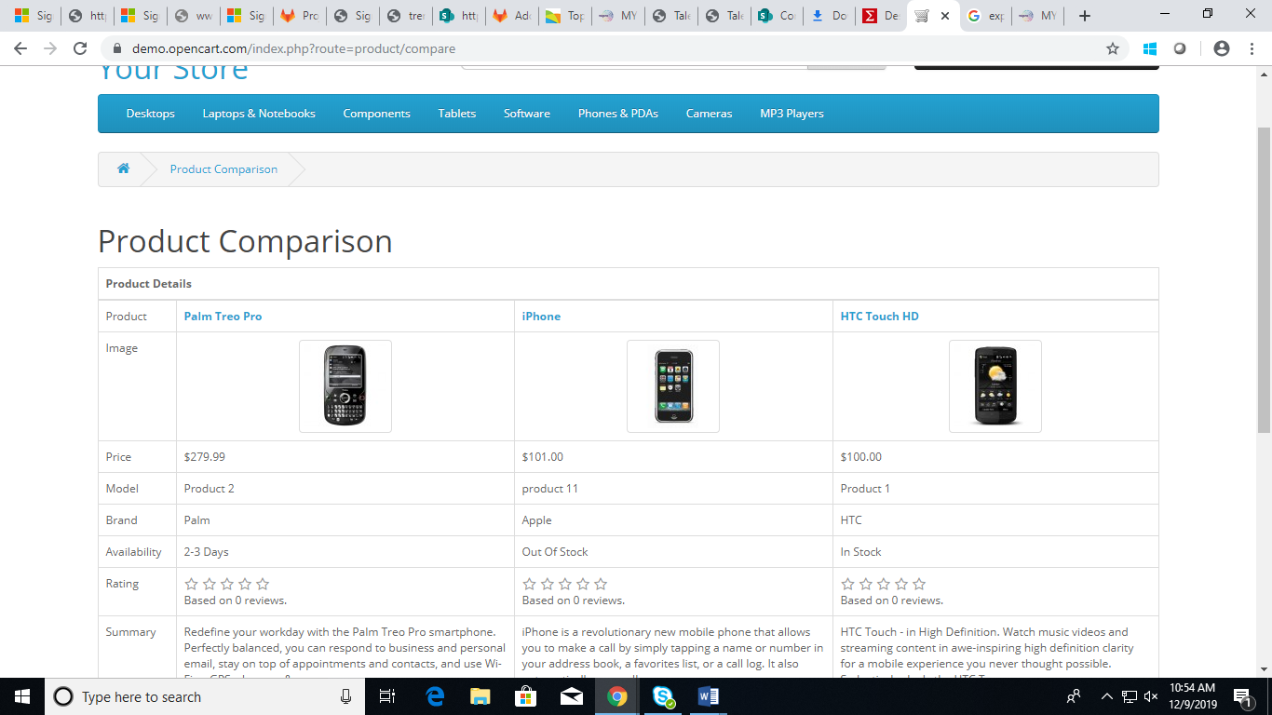

STEP 9: Click on the first phone link on the page

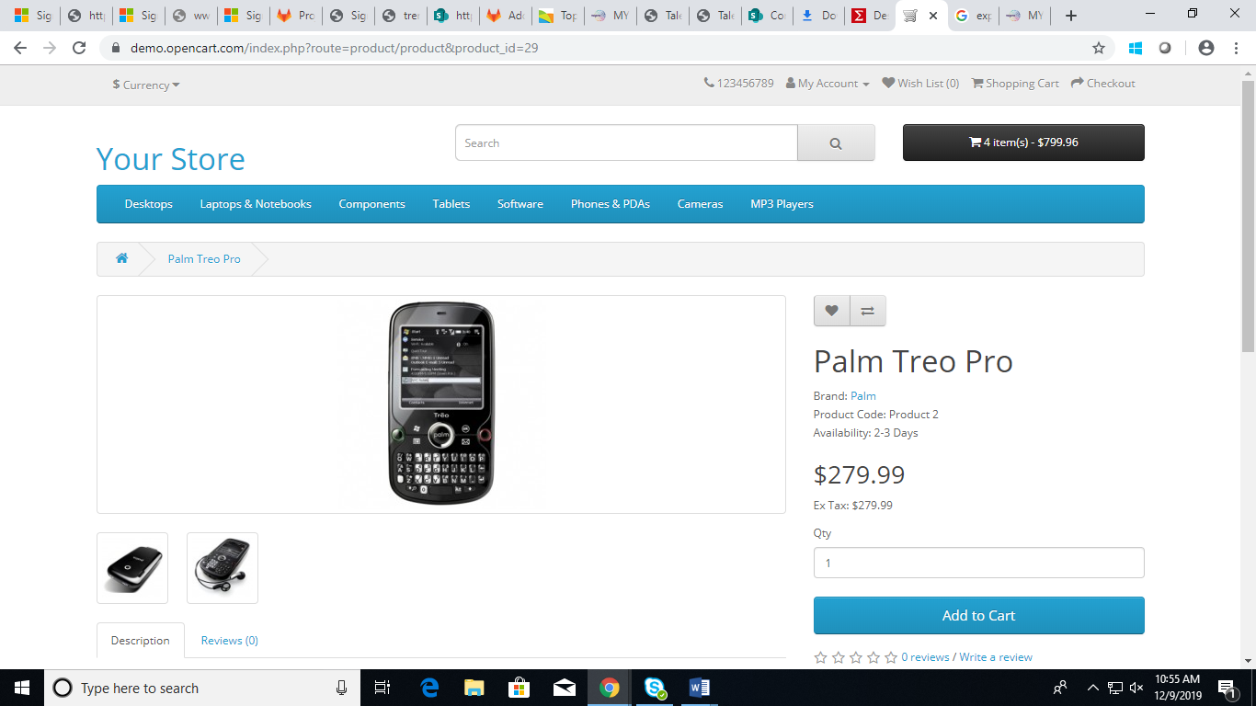

STEP 10: Check the fifth feature in the description section of the phone and write into flat file.

“Tri-band UMTS — 850MHz, 1900MHz, 2100MHz”

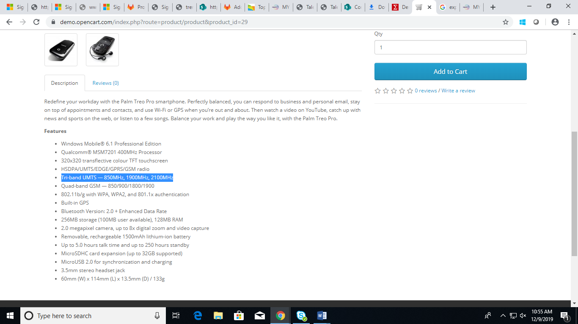

STEP 11: Click on "Add to Cart".

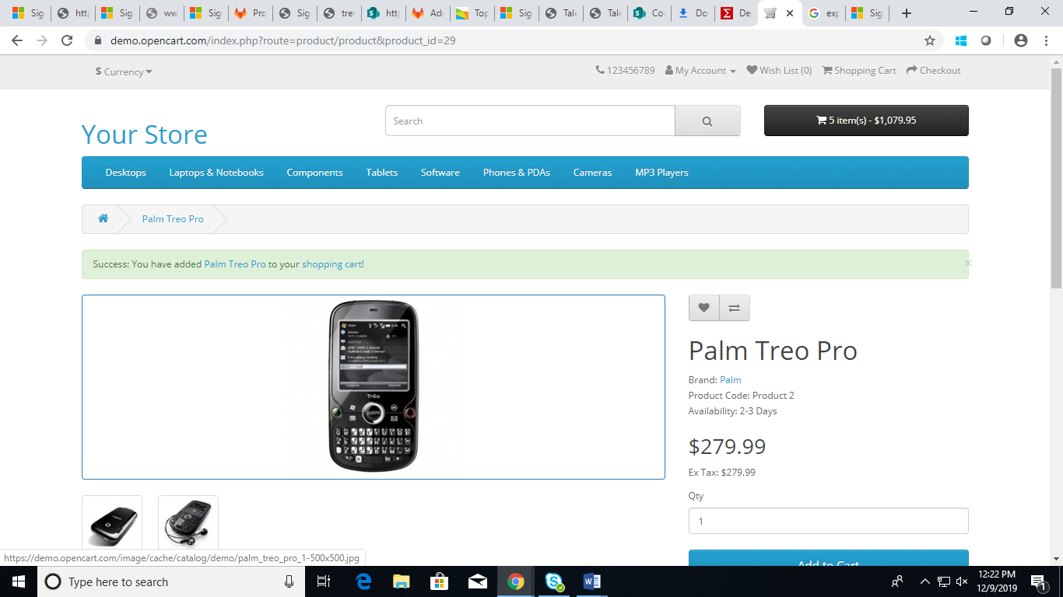

STEP 12: Click on "Shopping Cart" displayed on ribbon message

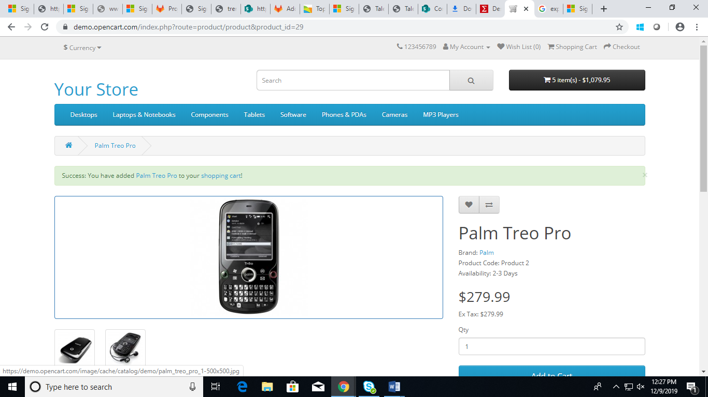

STEP 13: Click on Check out button

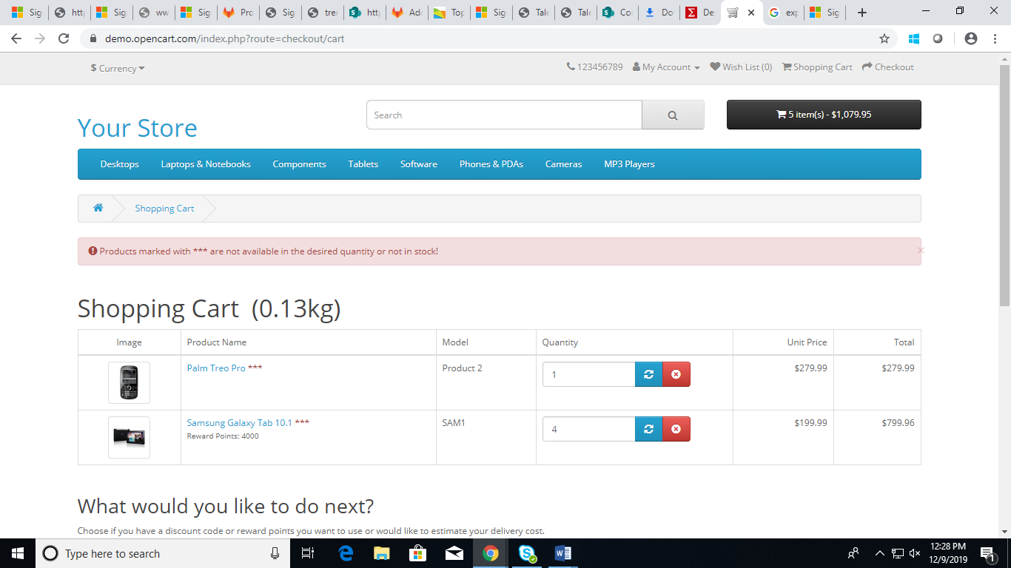

After this step Iam getting error as “**Products marked with *** are not available in the desired quantity or not in stock**” .

I couldn’t proceed further.